Smart Art Rubric
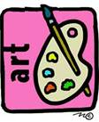 | Incomplete Art  0 points  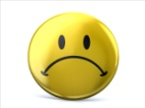 | OK Art  1 point  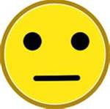 | Good Art  2 points  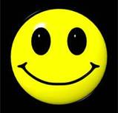 | Awesome Art  3 points  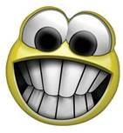
1.  Creativity | The artist did not come up with their own unique idea (Copied the example or neighbors) | There are some similarities to the example or neighbors. The artist added some detail | The artist came up with their own unique idea and added some interesting detail | The artist came up with their own unique idea with detail and demonstrates higher order thinking skills.
2.  Craftsmanship | The artist did not demonstrate proper technique and the artwork is not neatly completed | The artist demonstrated some proper technique and the artwork is somewhat neatly completed | The artist demonstrated good technique and the artwork is neatly completed | This artist’ demonstrated excellent technique and the artwork is exceptionally completed
3.  Understands learning objectives | The artist did not demonstrate any of the learning objectives for this project | The artist only demonstrated some of the learning objectives for this project | The artist demonstrated most of the learning objectives for this project | The artist demonstrated all of the learning objectives for this project
4.  Work Habits | The artist did not complete the assignment or used materials appropriately | The artist required prompting to complete the project and/or used materials appropriately | The artist generally used their time and materials wisely | The artist worked diligently and used materials properly

